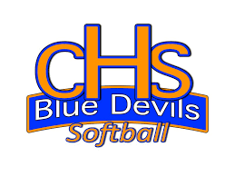
Dear Friend of the Lady Blue Devils Softball Team,
Thank you for taking an interest in our program and the upcoming 2021 softball season. We are excited about the season and all that we plan to accomplish on and off the field!
The Lady Blue Devils softball program is built on a commitment that comes from our players, coaches, families, and friends. We are extremely proud to have accomplished so much and we are optimistic of continuing these traditions for years to come.
Last year, we finished 1st round of state for GHSA AAAA and we hope to do even better this season. We are also #3 top school in the state of Georgia and our girls have some of the best GPA’s at our school. We pride ourselves on being successful student-athletes.
Each year, we look to those that are willing to support our efforts by allowing our girls to compete in tournaments, have team bonding experiences, and purchase needed equipment for the team. As well as other items needed to make our program a success.
We are asking for your support in any way that you feel lead monetarily so that we can fulfill our goals and needs for the 2020 season. Any amount would be much appreciated and will go directly towards each players fundraising goal to help purchase items for the team.
If you feel lead to support the team, please send a check back to the player that contacted you. You can hand deliver the check or mail it to the player.
We look forward to your support of the CHS LADY BLUE DEVILS Softball Program and updating you on our success this year!
Thank you for your support!
Jamie Wilson, Columbus High School Head Softball Coach
Lady Blue Devils Softball Team

